PREVENTITIONS TO AVOID COVID – 19

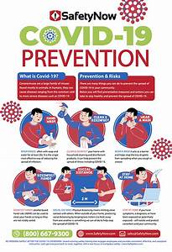

1. social distancing

Since close person-to-person contact appears to be the main source of transmission, [**social distancing**](https://healthmatters.nyp.org/what-to-know-about-social-distancing/) remains a key way to mitigate spread. The CDC recommends [**maintaining a distance of approximately 6 feet**](https://www.cdc.gov/coronavirus/2019-ncov/php/public-health-recommendations.html) from others in public places. This distance will help you avoid direct contact with respiratory droplets produced by coughing or sneezing.

2.Wash your hands

Wash your hands often with soap and water for at least 20 seconds, especially after you have been in a public place, or after blowing your nose, coughing, or sneezing.

3. Restrict your travel

Traveling can increase the spread of COVID-19 and put you at risk for contracting the disease.

4.Wear a mask

5.Avoid crowds and poorly ventilated spaces

6.Cover coughs and sneezes

### 7.Clean and disinfect

### 8.Monitor your health daily